

Via Fax: (573)751-8115
Mr. Joshua M. Cox
Missouri Department of Revenue
General Counsel’s Office
Post Office Box 475
Jefferson City, Missouri 65105-0475

RE: Petitioner: Nicholas Sobba
Docket No.: STCL0009
Case No.: AD23010184
DLN: X169157003
Hearing Date: January 17, 2024

Dear Mr. Cox:

Petitioner would like the Hearing Officer to review the documents on file with the Department of Revenue and make a decision based on these documents, having no additional evidence to submit.

Please call me right away if there is an issue with this request or if you should have any questions. Thank you for your assistance and your courtesy.

Sincerely,

John C. Schleiffarth #63222
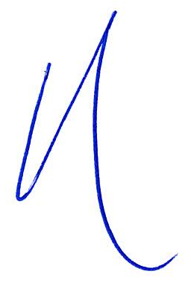
_/s/Andy Morris______________________
Andrew Morris #67504
75 West Lockwood Avenue, Suite 250
Webster Groves, Missouri 63119
Telephone: 314-561-9690
Facsimile: 314-596-0658
Email: john@jcsattorney.com
andy@jcsattorney.com
Attorney for Petitioner
JCS/taw
facsimile

